臺南市佳里區仁愛國小109學年度下學期
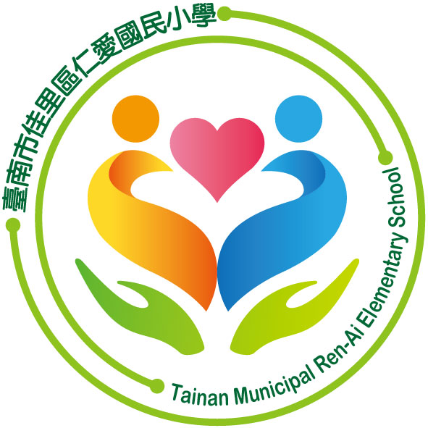

期末教師檢核
五年級：每週生活英語對話(Weekly Dialogue)
Class: Number: Name:
編號 | 主題及英語週句 |  |  | 學生檢核 | 家長檢核
Topic: Lantern Festival |  |  |  | 小關主簽名 | 家長簽名
1 | People solve riddles on the lanterns.
Topic: Friendship |  |  |  | 小關主簽名 | 家長簽名
2 | A |  | Can I play board games with you?
2 | B |  | Of course, my friend.
3 | A |  | Let’s play video games together.
3 | B |  | Sure! Let’s do it!
Topic: Easter |  |  |  | 小關主簽名 | 家長簽名
4 | A |  | Do you know that the date of Easter changes each year?
4 | B |  | Oh, really? I only know it’s always on Sunday.
Topic: April Fools’ Day |  |  |  | 小關主簽名 | 家長簽名
5 | A |  | Is April Fools’ Day a legal holiday?
5 | B |  | No, but it is popular around the world.
Topic: Children's Day |  |  |  | 小關主簽名 | 家長簽名
6 | A |  | When is Children’s Day?
6 | B |  | It’s on April 4th.
7 | There is no children, only people.— Janusz Korczak雅努什‧柯札克
Topic: Locations at school |  |  |  | 小關主簽名 | 家長簽名
8 | A | Excuse me, how to go to the science classroom?
8 | B | It’s on the third floor in Art Building.
Topic: Mother’s Day |  |  |  | 小關主簽名 | 家長簽名
9 | A |  | I’m going to draw a card to my mom this year. How about you?
9 | B |  | Well, I think I will give her a hug and a kiss.
10 | A |  | When is Mother’s Day in U.S.?
10 | B |  | It’s on the second Sunday in May as well as Taiwan.
Topic: Good Manners |  |  |  | 小關主簽名 | 家長簽名
11 | A |  | How to get along with your friends and classmates?
11 | B |  | Treat others the way you want to be treated.
12 | Don’t backbiting and gossiping behind your friends.
Topic: Dragon Boat Festival |  |  |  | 小關主簽名 | 家長簽名
13 | A |  | What do you do on Dragon Boat Festival?
13 | B |  | I help my grandapartents make delicious rice dumplings.
14 | A |  | My parents took me to see the dragon boat race.
14 | B |  | Wow! It must be very crowded.
Topic: Review |  |  |  | 小關主簽名 | 家長簽名
15 | Review (1-14)

